- Design Zero-shot, One-shot, and Few-shot prompts to generate a product description for a Smart Fitness Watch.

Zero-shot Prompt
Prompt:
Write an attractive product description for a Smart Fitness
Watch. Highlight its fitness tracking, heart rate monitoring,
sleep tracking, step counting, battery life, and stylish design.

Expected Output:
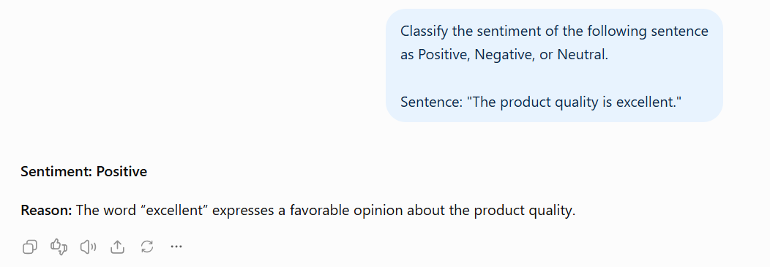
B. One-shot Prompt
Prompt:
Example:
Product: Wireless Earbuds
Description: Enjoy clear sound and comfortable listening
with wireless earbuds featuring noise reduction, long battery
life, and a compact design.
Now generate a product description for:
Product: Smart Fitness Watch
Include fitness tracking, heart rate monitoring, sleep
analysis, and stylish design.
Expected Output:
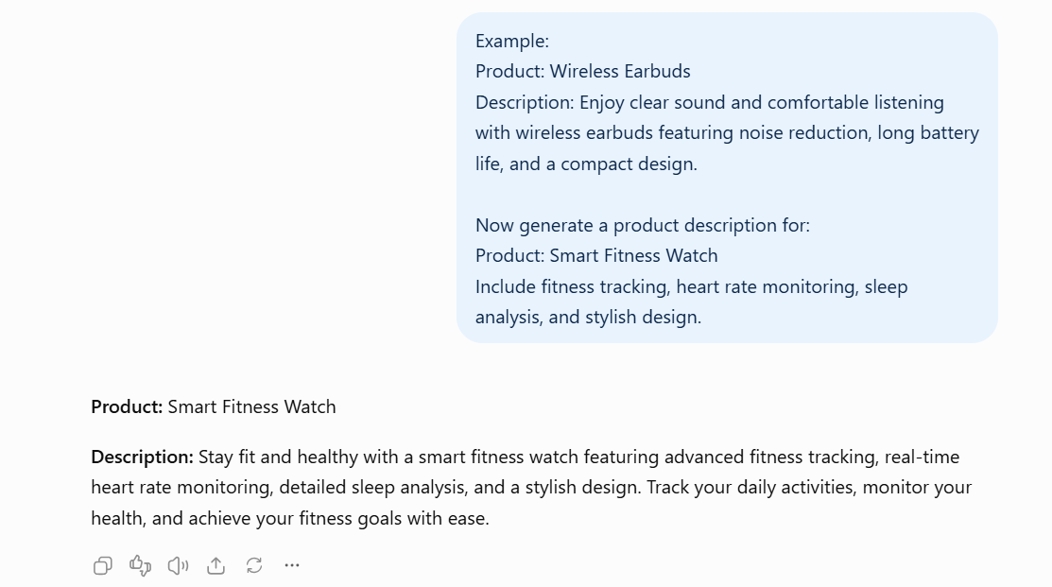
C. Few-shot Prompt
Prompt:
Example 1:
Product: Smart Water Bottle
Description: Stay hydrated with a smart water bottle that
reminds you to drink water and helps you maintain healthy
hydration habits.
Example 2:
Product: Wireless Headphones
Description: Experience immersive audio, comfortable
ear cushions, and wireless connectivity for music and calls.
Example 3:
Product: Smart Fitness Band
Description: Track your steps, monitor your heart rate,
and measure your daily activity with a lightweight fitness
band designed for an active lifestyle.
Now generate a product description for:
Product: Smart Fitness Watch
Include fitness tracking, heart rate monitoring, sleep
tracking, battery life, and modern design.
Expected Output:
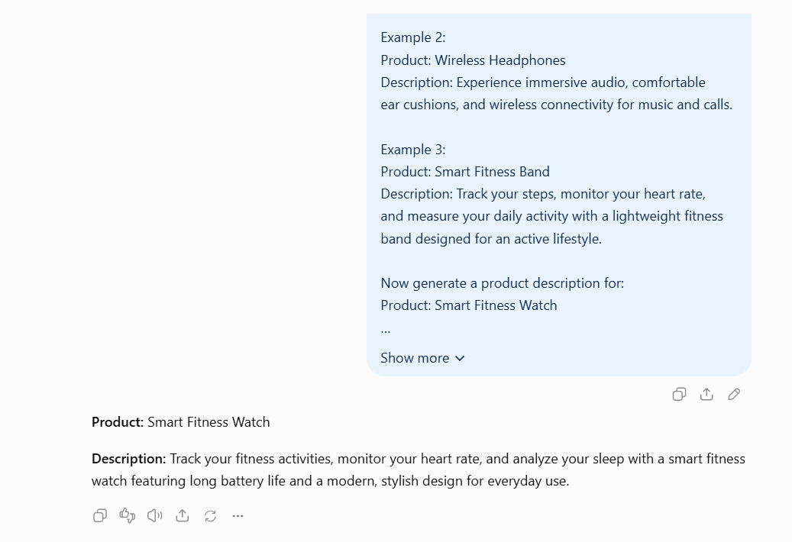
D. Comparison
Technique | Examples | Main advantage
Zero-shot | 0 | Simple and quick
One-shot | 1 | Demonstrates the expected writing style
Few-shot | 3 | Provides multiple examples for consistent output
Result
Zero-shot, One-shot, and Few-shot prompts were designed to generate a product description for a Smart Fitness Watch. Few-shot prompting provides more examples of the expected style, while Zero-shot prompting is faster and uses fewer tokens.

